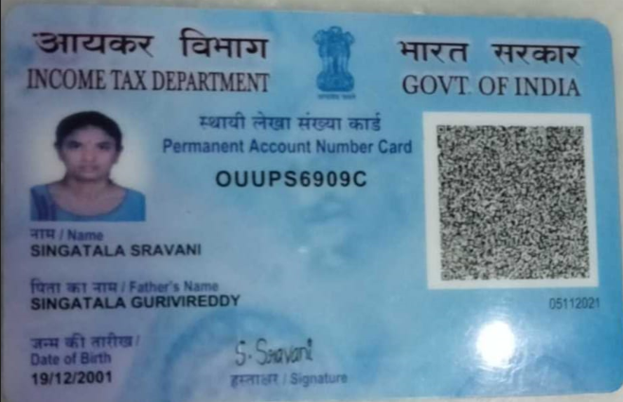

S. SRAVANI
Email id:sravschandra1@gmail.com
Phno: +91 8179619780

Oracle Fusion Technical Consultant

Summary

- Around 2.8 years of Software Development experience in Oracle Applications, Oracle Integration Cloud, Reporting Web services, Oracle ERP Cloud
- Good working Knowledge of Oracle Fusion Cloud Finance Technical (FBDI, BI Reports, & OIC).
- Good programming skills in SQL with successful implementation experience.
- Good Stake Holder Management
- Good knowledge of Oracle financials functionalities
- Well-versed in SOAP and REST web services (XSD, WSDL, XSLT).
- Good hands-on experience in SOAP, REST, ATP, FTP, ERP connections in OIC
- Demonstrated technical proficiency, good coordination, and communication skills on the job.
- Enthusiastic in acquiring and getting adapted to new technologies and practices.

Qualifications:

Course | Specialization | Name Of University
Degree  (2019-2022) | BSC(Computer Science) | Yogi Vemana University, Kadapa

Technical Skills:

ERP | Oracle ERP Cloud
Modules | Account Payables, Procurement, Order Management
Operating Systems | WINDOWS 10 & 11
Technologies | SQL,pl/sql, OIC, Webservices(SOAP & REST), FBDI Conversions, BIP

work experience #

- Working as Oracle Fusion Technical Consultant in Epoh Tech from oct 2024 to till Date.

Professional Experience
Project Name: MYEYEDR oct 2024– Present
Technology: Oracle ERP Cloud, OIC
Summary: MyEyeDr is a leading eye hospital implementing Oracle Financials and Order Management, migrated from EBS. The project integrates partner applications (SFDC, CPQ) using OIC.
Developed OIC integrations.
Gathered requirements and created technical design/test case documents.
Integrated Employee details from Dayforce to ERP using OIC.
Developed mappings and performed unit testing.

(UNITEL SOFTWARE LIMITED)
Project Name: LCE OTC Implementation May 2022 – sep 2024
Technology: Oracle ERP Cloud, OIC, BI Publisher, Web services, FBDI
Summary: Little Caesar Enterprises Inc. is an American multinational chain of pizza restaurants that was founded in 1959. Little Caesars is the third largest pizza chain by total sales in the United States behind Pizza Hut and Domino’s. It operates and franchises pizza restaurants in the United States and internationally in Asia, Europe, the Middle East, Canada, Latin America, and the Caribbean. On behalf of businesses and governments – creating exceptional outcomes for its clients. Little Caesar is implementing Oracle SAAS and PAAS, for Integrations using OIC and ADF for Custom solutions.
Responsible for the solution design, development of OIC Integrations.
Developed BI Publisher reports, Creating Jobs.
Scheduled ESS (Enterprise Scheduler Service) Jobs to automate recurring tasks and ensure timely execution of critical processes within Oracle Fusion applications.
Developed several Mappings as per the requirements.
Performed unit testing at various levels of flow.

- PERSONAL DETAILS:

- Name : Singatala Sravani
- Father’s Name : Singatala GuriviReddy
- Date of Birth : 19-12-2001
- Gender : Female
- Nationality : Indian
- Religion : Hindu
- Languages known : English, Telugu.
- Address : H.No: 26/931-7-2-1,Rameshwaram,Mittamadi Street
- Proddatur, District, Kadapa, 516360, AP
- Hobbies : Travelling, Browse using the Internet

- Declaration:

- I hereby declare that the above-mentioned information is correct up to my knowledge and I bear the responsibility for the correctness of the above-mentioned particulars.

SRAVANI SINGATALA

